**Salesforce Admin**

TTop Companies that use Salesforce today

op Co

|  |  |
| --- | --- |
| **Company Name** | **Industry** |
| Aricent Group | Telcom |
| Aricent Inc | Telcom |
| BlueScope Steel | Manufacturing |
| KONE | Manufacturing |
| Cisco Systems Inc | Computers and Electronics |
| Motorola Inc | Telcom |
| Yamaha Corporation | Wholesale and Distribution |
| Allianz AG | Financial Services |
| Spherion Corporation | Business Services |
| P&H Mining Equipment | Manufacturing |
| Thomson Reuters Corporation | Financial Services |
| VTB Capital plc | Financial Services |
| Swiss Re Corporation | Financial Services |
| BNP Paribas Limited | Banking |

CRM, collection of databases, SaaS, PaaS, Org that provides software services…software that unites customers and org…multi tenant operation

Sales cloud >> Payment system >> Delivery system

Mulesoft – Purpose : To integrate with other systems.

**Key points to remember:**

* Runs on cloud
* Can be accessed via a browser and a stable internet connection
* Multi-tenant environment

**Learning environment setup:**

**Step 1:** [**https://trailhead.salesforce.com**](https://trailhead.salesforce.com) **– Use this to create a sample product instance for training and learning purpose**

**Step 2: Create a playground org**

**Company setup:**

**Terminologies used in SF eco system:**

* **Standard**
  + **Anything that’s is available inbuilt or out of the box**
* **Custom**
  + **Anything that you create as a developer or admin**
* **Tabs**
  + **Nothing but navigation menu links**
* **Object**
  + **Nothing but table in the database**
* **Org**
  + **Refers to an environment or an instance of Salesforce product**
  + **You can have a specific purpose (development, testing, production, training, learning) associated to an org**
* **Sandbox**
  + **Nothing but a non-prod environment**
  + **Eg:** [**https://gibsonguitar2--spmdev.sandbox.my.salesforce.com/**](https://gibsonguitar2--spmdev.sandbox.my.salesforce.com/) **- Developer Org**
  + [**https://dealer--b2bpartial.sandbox.my.salesforce.com/**](https://dealer--b2bpartial.sandbox.my.salesforce.com/) **- SIT Org**
  + [**https://gibsonguitar2.my.salesforce.com/**](https://gibsonguitar2.my.salesforce.com/) **- Prod org**

**Features List in SF system:**

* **User Login**
  + **3 ways to login**
    - **Direct user name and password (login.salesforce.com)**
    - **Via trailhead – Launch option (Only used during training or learning purpose)**
    - **Single sign on by integrating Salesforce org with Company’s active directory (MZ Azure Directory, IBM Tivoli etc)**
* **Profile**
  + **A way to group users in the system**
  + **User – Profile mapping (1:1)**
  + **Can use profile to define user security / access in the org**
  + **WHAT USER CAN DO IN THE SYSTEM**
* **Permission Set**
  + **Helps users to have elevated access in the system**
  + **Part of security feature and works along with Profile**
* **Page Layout**
  + **Used to control fields to be shown on a page**
  + **One can use Std. page layout and edit to meet the needs**
  + **Or create a custom page layout to configure fields on the page**

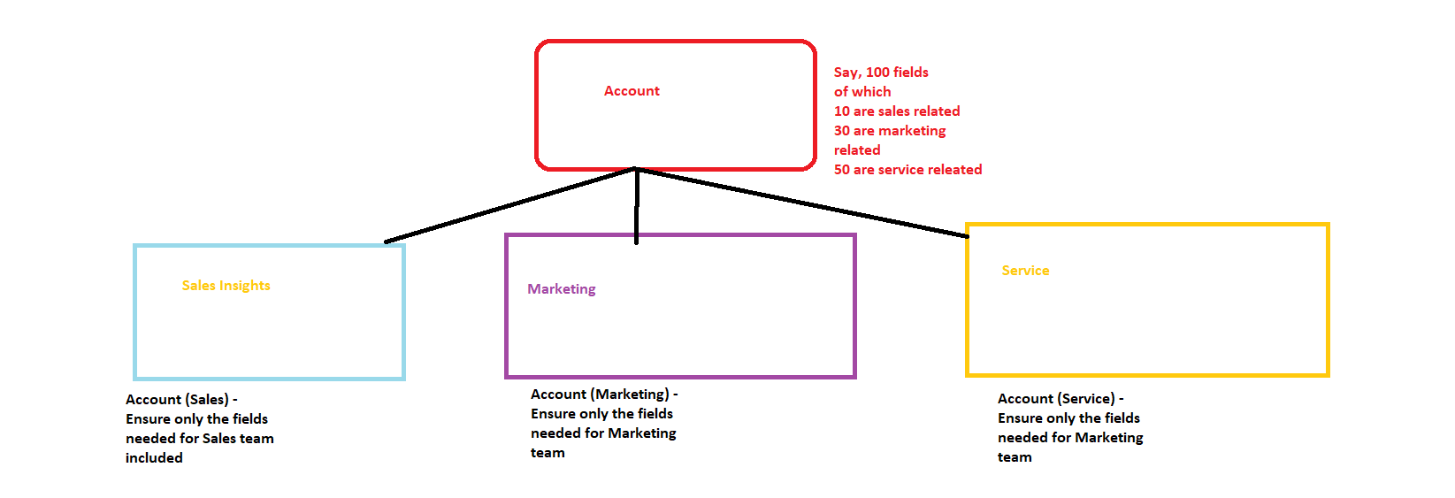

* **Dynamic Forms**
  + **Adv. Version of page layout**
  + **You can choose a page layout and upgrade to Dynamic forms**
  + **Helps to make ur page dynamically change based on user input**
* **Salesforce Id**
  + **A unique value that gets generated when a record is created in the system**
  + 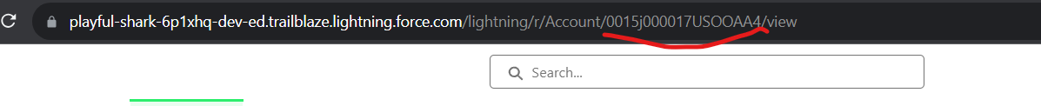
* **Recycle bin & its significance**
* **Developer Console & Query Editor**
* **Email Template (Classic / Lightning Templates)**
* **Activities Component**
  + **Helps to manage tasks, to do list, sending one on one email, managing calendar**
* **Data Relationships**
  + **Type 1: Master Detail Relationship**
    - **Eg: Deleting an order will remove all the associated order line items**
      * **Deleting an account will remove all the associated contacts and opportunities**
    - **Tightly coupled relationship between 2 objects**
  + **Type 2: Lookup Relationship**
    - **Eg: Deleting an account will not remove the associated account owner(user)**
    - **Loosely coupled relationship between 2 objects**
  + **Many to Many Relationship**
    - **Achieved thru create a custom object acting as a junction or bridge to relate 2 objects**
    - **Create 2 master detail relationship**
    - **Ref:** [**https://www.salesforceben.com/what-is-a-junction-object-in-salesforce/**](https://www.salesforceben.com/what-is-a-junction-object-in-salesforce/)

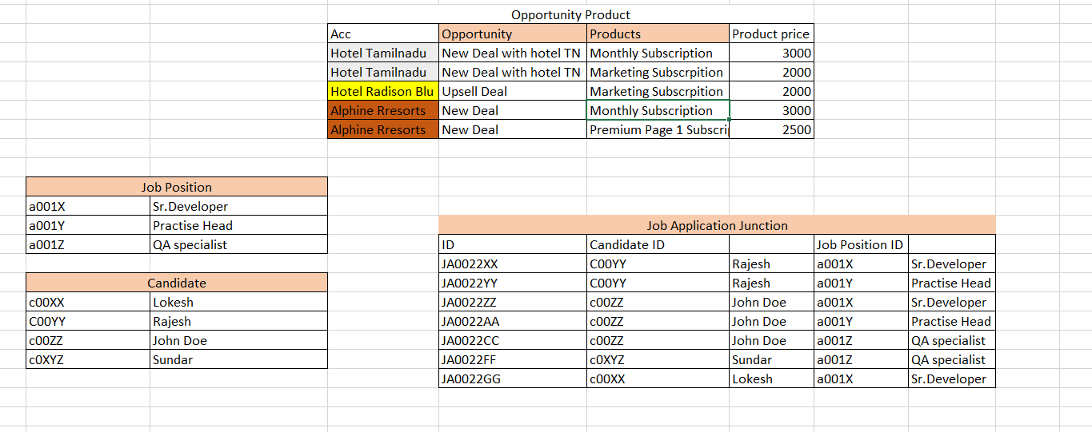

* + **Direct Relationship**
  + **Indirect Relationship**
* **Data Load / Import Options**
  + **Option 1: Data Import Wizard**
    - **Limitations:**
      * **Supports only a few Std. objects for data load**
      * **Max. 50K records can be loaded**
      * **Cannot delete records**
      * **Cannot be used to load files**
  + **Option 2: Data Loader**
    - **Supports all std. and custom object**
    - **Max. 50 Million records can be loaded**
    - **Can delete records**
    - **Can export records**

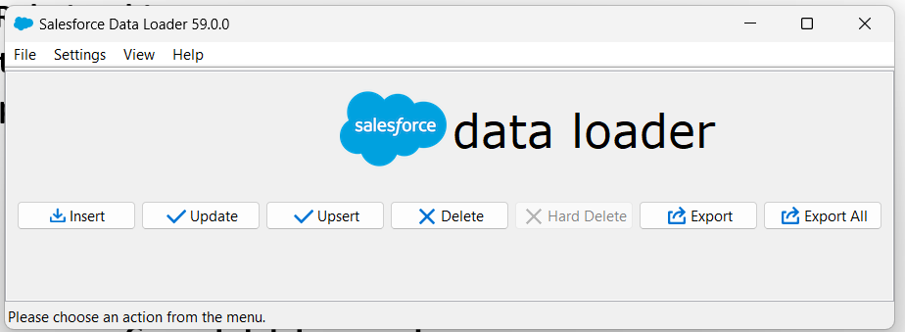

* **Reports**
  + **Tabular Report**
    - **Simple rows and columns**
    - **No Add chart functionality is available**
  + **Summary Report**
    - **When u apply grouping against a column**
    - **Add chart functionality will be available**
  + **Joined Reports**
    - **Use it to group data from multiple objects**
    - **Records can be grouped by a common field that connects all the data**
    - **E.g: Account Name can be used to group account & contact; account & roomtype ; account & cases; account& opportunities**
* **Custom Report Type**
* **Lightning Page / UI changes - TIP**

|  |  |  |  |
| --- | --- | --- | --- |
| **Section** | **Page Layout** | **Dynamic Forms** | **Edit Page option** |
| **Details** | **Yes** | **Yes** | **No** |
| **Related List** | **Yes** | **No** | **No** |
| **New Record Page Tabs** | **No** | **No** | **Yes** |
| **Add or Remove components** | **No** | **No** | **Yes** |
| **Highlights Panel** | **Yes** | **Yes** | **No** |

* **Public Groups**
* **Significance of share object**
* **Audit Trail**
* **Data Visibility or Data Security or Data Sharing**
  + **Underlying Principle** 
    - **Record Ownership** 
      * **The user that created a record becomes the owner of the record**
  + **Per current setup for account object**
    - **Rajesh - 19 Partner hotel records. In total 36 account records**
    - **Sales Team - John Doe - 19 Partner hotel records. In total 36 account records**
    - **Legal Team - Jimmy Carter - 19 Partner hotel records. In total 36 account records**
    - **The above state of data visibility configuration is called “Organization Wide Defaults (OWD)”**
    - **“Profile level Data administration Or Permission set level data administration”**
    - **Manual Sharing**
    - **Sharing Rules**

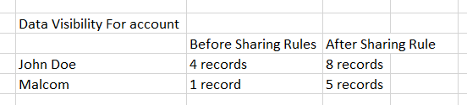

* + - **Role Hierarchy**
    - 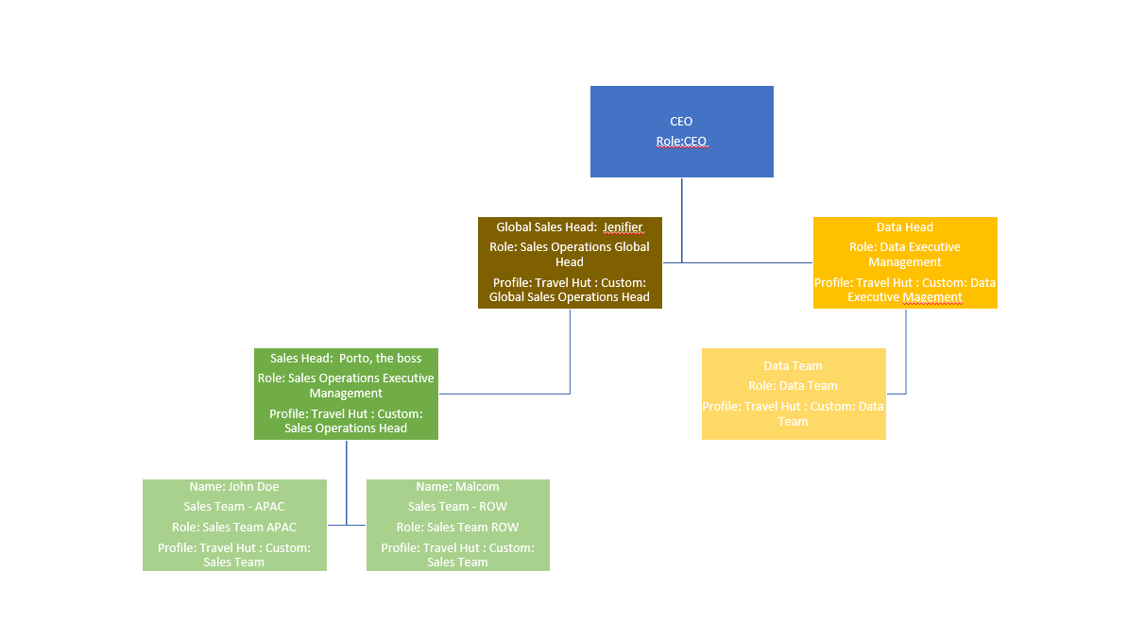
  + 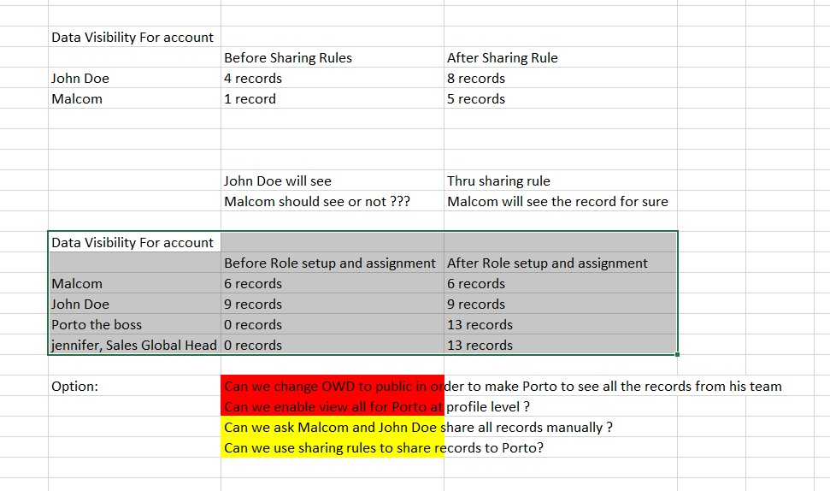

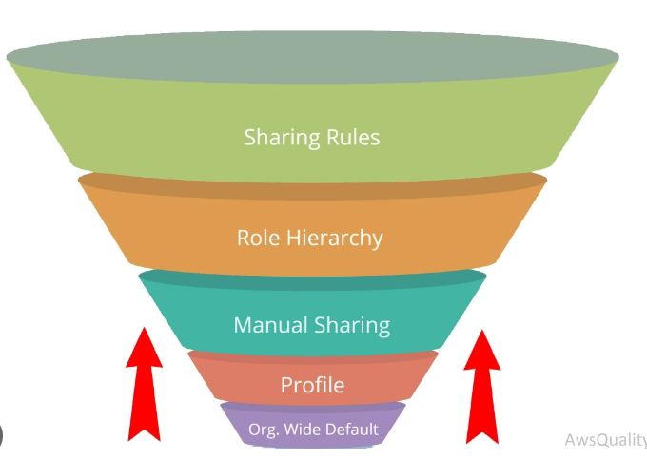

* **Formula Fields**
  + **Usage #1: Derive new values based on other field values**
  + **Usage #2: Access related object field values**
* **Custom Validation rules** 
  + **To validation user input on the screen**
  + **Runs during create & update**
* **Lead Management & Account Conversion process**
  + **Potential Customer (Interested but not doing business with )**
  + **Conversion process**
    - **Helps to create account , contact & opportunity automatically**
    - **Also, to copy custom data from lead to other objects against (account, contact & opportunity), user can use lead map fields option**
    - **Use reports to show converted leads information to users**
* **Chatter**
  + **Collaboration platform within Salesforce**
* **App Exchange**
  + **Nothing but a market place for Salesforce apps, consultants, industry based solutions**
* **Lightning App builder**
  + **Custom app page**
  + **Custom Record Page**
  + **Custom Home page**
    - **Ability to create home / record / app page and configure components relevant for users**
* **Multi-language support**
* **Multi-currency support**
* **Approval process**
* **Record Types**
* **Field tracking**
  + **Option 1: Use Field History tracking from Object Fields and Relationship**
    - **Limitation | Max. 20 fields can be tracked**
    - **Reportable**
    - **Related List available for doing review in UI**
  + **Option 2: Chatter Feed**
    - **Non reportable**
    - **Related list not available**
* **Automation** 
  + **Option 1: Work Flow** 
    - **Cannot be used as its in sunset path**
  + **Option 2: Process builder**
    - **Cannot be used as its in sunset path**
  + **Option 3: Salesforce Flow**
    - **Type of Flow**
    - **Key Pillars**
      * **Resource**
        + **Variables**
        + **String szName = ‘VAnji’**
        + **Number x =4 ; Number y = 3; string azName = ‘Rajesh; Number z = x + y;**
      * **Data Elements**
      * **Interaction Elements**
      * **Logic Elements**
* **Web to lead**
* **Web to case**
* **Storage Usage**

**Objects & Purpose**

|  |  |  |
| --- | --- | --- |
| **Type** | **Name** | **Purpose** |
| **Standard** | **Account** | **Meant to store customer information** |
| **Standard** | **Contact** | **Meant to store business contacts, customer contact etc, external user data or named person** |
| **Standard** | **Case** | **Meant to store customer issues and also internal issues or problem / incident management** |
| **Standard** | **Opportunity** | **Meant to store business deals**  **E:g Technology Services, BPOs** |
| **Standard** | **Opportunity Product** | **It is a junction object to link multiple opportunities and products** |
| **Standard** | **Product** | **Meant to store customer master list of products being sold** |

**Org Users**

|  |  |
| --- | --- |
| **CEO** | **Mithran** |
| **Sales Manager** | **Malcom** |

**Use case #1:**

**As an admin, how can I modify the std. marketing app so that it will have ‘Account’ tab included:**

**Solution:**

* **Use app manager from setup**

**Use case #2:**

**CEO of travel hut has identified a Sales Manager named ‘Malcom’. You have been tasked to onboard the Sales Manager**

**Solution:**

* **From setup use ‘Users’ option**
* **‘Users’ feature will help to create and manage org. users**
* **Create Sales profile and add user to it**

**Use case #3:**

**Malcom has raised a concern that his UI is not very friendly . Also, he is not seeing Sales app for him to manages customers, contacts etc**

**Solution:**

* **Enable access to Lightning UI to the Sales profile**

**Use case #: 4**

**CEO of travel hut would like to ensure ‘Malcom’ is able to manage hotel partner customers and customer point of contacts & reports alone when logged into the system**

**Solution:**

* **Use app manager and create a new custom app**

**Use case #: 5**

**Malcom has raised a concern that in his UI he is able to more apps besides “Sales Insights”.**

**How as a sys admin you will configure the app launcher UI for Malcom?**

**Solution:**

* **Login as Malcom and check on his App launcher apps**
  + **Pre-req: Enable Login as user policy from setup and Uncheck force relogin after login-As-user**
* **Use “Profile” to set app security for Malcom**

**Use case #: 6**

**CEO of Travel Hut would like to onboard a new Sales Director named ‘John Doe’ who will oversee Sales Operations. Sales Director must have access to Sales Insights, Sales and Marketing apps**

**Solution:**

* **Create a new user John Doe and assign with “**[Travel Hut : Custom: Sales Team](javascript:srcUp(%27%2F00e5j000000asI3%3Fisdtp%3Dp1%27);)”
* **Use “Permission Set” to give elevated or special access to John doe so that he can see marketing app in addition to Sales apps**

**Use case #: 7**

**CEO and Sales Director would like to ensure only relevant fields are displayed on account / customer page. So that, Sales team can enter only the information related to hotel partner and resorts**

**Solution:**

* **Use “Page Layouts” or “Dynamic Forms”**
* **Option 1 : Page Layout**
  + **Create a new Page Layout**
  + **Use Page layout assignment option**

**Use case #8:**

**Sales Team would like to store more information on the new hotel / account create page. The list of data points to be captured are given below**

* partner hotel image
* Location (Reuse BillingCountry)
* Customer Rating
* Total Rooms Available
* Hotel Lat
* Hotel Long
* Hotel Category ( 2 star, 3 star, 5 star, 7 star)
* Room Types (Suite, Doubel, Single, Family, Penthouse) – Cannot be a drop down
* Amenities (Parking, Gym, Swimming Pool, Resturantants, In-house dinning, Bar)

**Solution:**

* Create custom fields on Account object

**Use case #9:**

John Doe (Sales Director) would like to see additional information when hotel partner account is created in the system.

Ensure the below fields are available only for Sales Director and no Sales Team member

* Legal Review (Sent for review, In Progress, Approved)
* Legal Reviewed By (user that is assigned for legal review)
* Agreement Needed ? (If yes, then allow user to choose between the 2 agreements)
* Agreement
  + Exclusive Partnership Agreement
    - Start date , End date, Description
  + Marketing Collabration Agreement
    - Start date , End date, Description
* Eligible for Discounts & Promotions
  + Seasonal Promotions with 10% discount
  + Seasonal Promotions with 15% discount
  + New Customer Onboarding discount

Solution:

Option 1: ~~Roles . Roles can be used only to define data security~~

Option 2: Page Layout

* ~~Can we create a new page layout and assign to John Doe~~
* ~~Can we create a new page layout and assign to John Doe’s profile~~
* Can we use permission sets ?

**TIP : PAGE LAYOUT FIELDS SECURITY FLOW**

PAGE LOADS

🡪 SYSTEM CHECKS THE USER PROFILE 🡪 THOSE FIELDS THAT ARE MARKED AS VISIBLE OR READ ONLY WILL BE SHOWN ON THE PAGE

🡪 SYSTEM CHECKS THE USER PERMISSION SET 🡪 IF THERE IS ANY PERMISSION SET DEFINING FIELD READ ONLY OR EDIT ACCESS THEN THOSE FIELDS WILL BE SHOWN ON THE PAGE

**Use case #10:**

John Doe raises a concern that the system is showing lot of fields. For e.g agreement related fields should be shown only when agreement needed checkbox is selected.else it should be hidden from user view

**Solution:**

**Option 1:** ~~Page Layout . Cannot be done as dynamic fields setup not possible in page layout feature~~

**Option 2: Dynamic Forms**

* Another functionality in SF helps to configure UI fields
* Helps to configure fields that will show or hide based on visibility filters

**TIP : PAGE LAYOUT + DYNAMIC FORMS FIELDS SECURITY FLOW**

PAGE LOADS

🡪 SYSTEM CHECKS THE USER PROFILE 🡪 THOSE FIELDS THAT ARE MARKED AS VISIBLE OR READ ONLY WILL BE SHOWN ON THE PAGE

🡪 SYSTEM CHECKS THE USER PERMISSION SET 🡪 IF THERE IS ANY PERMISSION SET DEFINING FIELD READ ONLY OR EDIT ACCESS THEN THOSE FIELDS WILL BE SHOWN ON THE PAGE

🡪 IF DYNAMIC FORMS ENABLED

* SYSTEM CHECKS THE FIELD VISIBILTY 🡪 IF VISIBILTY CONDITION IS TRUE THEN FIELDS WILL BE SHOWN ON THE PAGE

**Use case #10:**

John Doe would like to send promotional email to one of his customer from Salesforce directly

Solution:

* Send email option from activities

**Use case #11:**

Say, sales team has closed many new deals and wanting to create new hotel customers in bulk in one go.

Solution:

* 2 options
  + Data Import Wizard
  + Data loader

**Use case #11:**

Say, Data team has requested to see all the account and contact and opportunities exported to review offline

Solution:

Option 1 : Create a report with account, contact & opp. Use export option to download

~~Option 2: Query Editor??~~

Option 3: Use Data Loader . However, it will export one object data at a time

Option 4: Use Data Export option

**Use case #12:**

CEO of TravelHut would like only the Data team in the system should have access to export data from reports. Other users should not be able to export or should not see export option in report

Solution:

* TODO

**Use case #13:**

**CEO would like to ensure Data team has access to all accounts in the system. However, data team should not have edit access to account records that they do not own.**

**Solution:**

* **Per setup, account is private’**
* **Use profile level data administration and enable “View all” access so that any user part of data team can see all accounts**

**Use case #14:**

Sales user John Doe would require assistance from legal team member to review contract clauses for a newly created hotel named ‘Green Coconut Resort’.

Solution:

* Per OWD setup, account is private
* Per profile data setup for legal team, View all is disabled
* Use “Manual Sharing” to manually override OWD and profile data configuration and share record to the specific user

**Use case #15:**

CEO would like to manage accounts for sales users in a better way.

Sales user John Doe should manage hotel partners in APAC

Sales user Malcom should manage hotel partners ROW

Solution:

* Automated way to share records based on a condition or ownership
* Sharing Rules
  + Can have more than one sharing rule for an object

**Use case #16:**

When a sales user adds contact of type business , ensure phone is made mandatory only for Sales Team users and also copy phone information into other phone fields like (work phone, mobile)

Solution:

* Use Salesforce Flow
  + Type: Record Triggered Flow
  + What did we learn
    - Configuring a flow
      * with start conditions
      * with decision element
      * with variables and its significance
    - Use of update records data element

**Use case #17:**

Extend the above functionality to ensure that the system does not override home phone if there is already a value which is different than Phone

Solution

* Record Triggered Flow
* What did we learn
  + Use variables
  + Use decision to supply dynamic values to variable

Use case #18:

When a sales user modifies payment info of a customer, system should automatically submit the record for approval. This will avoid an additional manual step for submitting the record

Solution:

* Use Record Triggered Flow
* Object Name: Account
* Trigger: Only on update
* Start Conditions: check for payment info change then start with automation steps
* Automation
  + #1: Find the approval process and auto submit

**Open items:**

1. How do we import data? - DONE
2. How do I create my own fields to store information? – DONE
3. Can I associate same contact to multiple accounts? - DONE
   1. Ex: Same PRO can be part of more than one hotel.
4. Can I copy contact work phone to personal phone automatically?
5. How do I know where my org’s data center is located - DONE
6. Why don’t I see master-detail relationship option in an object ? - DONE
   1. 2 reasons
      1. No std. object can be configured as child
      2. Max. 2 master detail relationship fields are allowed per object
7. How do I enable communication between users and contacts within Salesforce ?
8. How do I automate sending emails in Salesforce?
9. I have a data upload scenario to load account and opportunity. But, I don’t find any report type that helps me to build report fields having account and opportunities together? - DONE
   1. Use Report Type feature
10. How do I relate account , room type and contacts so that I can create a report? - DONE
    1. Not possible cos room type and contacts are not related to each other
11. Can system admin be automatically notified when manually a record is shared ? – Use automation process
12. How are we tracking activities performed by sys. Admin. – Use Audit trail
13. How can we send a record for auto approval instead of manually submitting record for approval?

**TODO**:

1. How do you assign a page layout at user level instead of profiles? – DONE
   1. Use Dynamic Forms
2. How do I customize links that are shown ‘All Items’ section inside App launcher
3. Why are we seeing this error in Data loader?

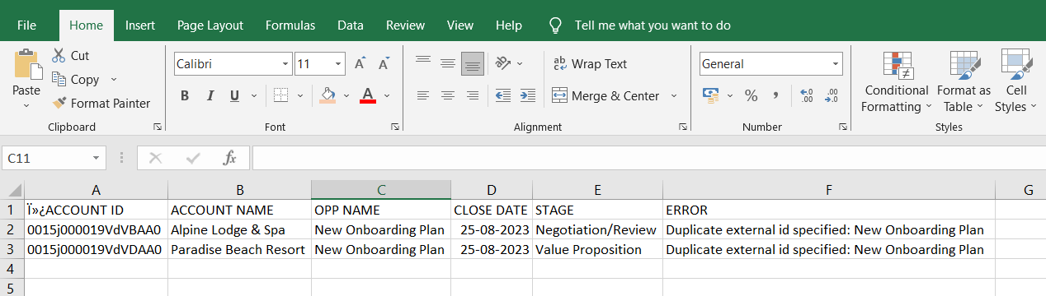

1. How to disable export option for users in Salesforce